**Class V**

**Basic: Window XP**

* Element of Window Screen
  + The Desktop
  + Icons and their types
  + The taskbar
* Various types of Window
  + Application Window
  + Document Window
* Elements of a Window
  + Border
  + The Title bar
  + The Control Box
  + Scroll Bars, Scroll Boxes and Scroll Button
  + The Menu Bar
  + Shortcut Menus
  + Dialog Box
  + Dialog Box Tabs
* The MYCOMPUTER ICON
* The RECYCLE BIN
* WORKING WITH FILES AND FOLDERS
* BASIC WINDOW ACCESSORIES
  + 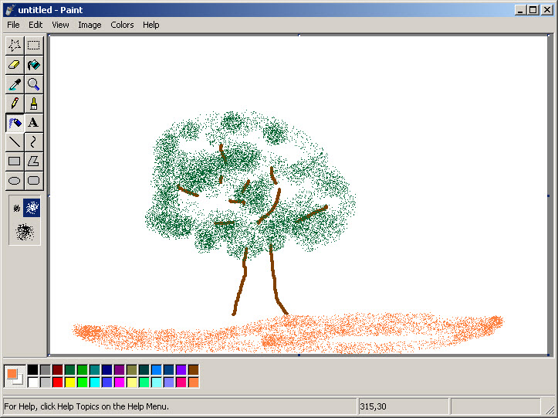Calculator
  + Notepad
  + WordPad
  + Paint

**Microsoft Paint**

* Introduction
* Opening Paint Program
* Saving paint document
* Opening an existing paint
* Overwriting on previous drawn paint
* Differentiate b/w SAVE and SAVE AS
* Closing paint program
* TOOL BOX
  + Free-form Selection****
  + Select
  + Eraser/Color Eraser

**Tool Box**

* + Fill with Color
  + Pick Color
  + Magnifier
  + Pencil
  + Brush
  + Air Brush
  + Text
  + Line
  + Curve
  + Rectangle
  + Polygon
  + Ellipse
  + Rounded Rectangle
* COLOR BOX
  + Basic Color
  + Color -> Edit Color

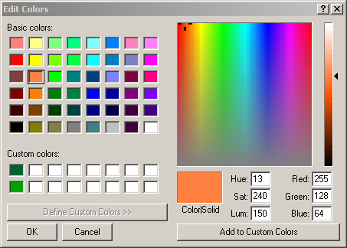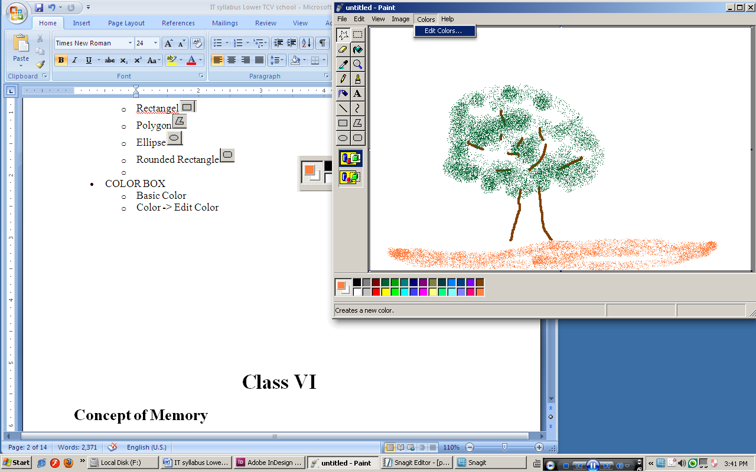

* MODIFICATION ON IMAGE
  + Flip/ Rotate
  + Stretch / Skew
  + Invert Color
  + Attributes
  + Clear Image
  + Draw Opaque
  + COPY
  + PASTE
  + CUT
  + PASTE FROM
  + Clear SELECTION

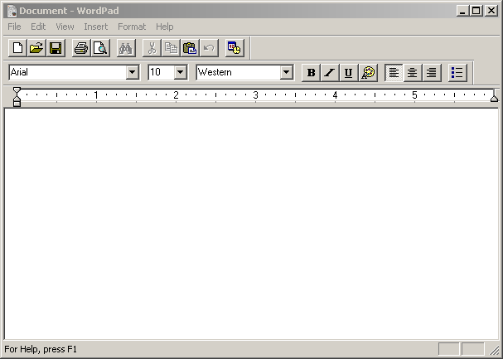**Microsoft Wordpad**

* Introduction
* Opening Wordpad
* Saving document
* Opening an existing document
* Overwriting on previous document
* Differentiate b/w SAVE and SAVE AS
* Closing Wordpad program
* STANDARD TOOLBAR
  + 
  + New Document
  + Open Document
  + Save Document
  + Print Document
  + Print Preview
  + Find
  + Cut
  + Copy
  + Paste
  + Back
  + Date Insertion
* FORMATTING TOOLBAR
  + 
  + Font
  + Font Size
  + Font Script
  + Bold
  + Italic
  + Underline
  + Color
  + Left Align
  + Center Align
  + Right Align
  + Bullet List
* INSERTION
  + Date Insertion
  + Object Insertion
    - Inserting Paint Program
    - Inserting Excel Worksheet
    - Inserting Power Point Slide
    - Inserting Media File

**Class VI**

**Concept of Memory**

* Unit of Memory
* Bit
* Nibble
* Bytes
* Conversion of Decimal to Binary Number
* Conversion of Binary Number to Decimal Number
* Primary Memory
* Secondary Memory
* Hard Disk
* Floppy
* CD ROM
* DVD
* Pen drive/Flash Drive/Thumb Drive/ Memory Stick)
* Memory Card
* External Hard Disk
* RAM ( Random Access Memory)
* ROM ( Read Only Memory)
* Input Device
* Output Devices

**Monlam Bodyig Version 3 : Unicode**

* Requirement of Tibetan Input Software
* What is TCRC Bodyig
* What is monlam 2
* Why Monlam Bodyig 3 Unicode
* What is Unicode
* Advantages of Monlam 3 over other Tibetan Input Softwares

**Microsoft Office 2003 Basic**

* Introduction
* Why Microsoft Office 2003
* Creating a Document
* Typing Text (English)
* Saving a Document
* Typing Tibetan ( use of Ctrl+Shift)

**Bodyig Typing**

* གསལ་བྱེད་སུམ་ཅུ། ༼ཀ་ཁ ག་ང་། ཅ་ཆ་ཇ་ཉ། ཏ་ཐ་ད་ན། པ་ཕ་བ་མ། ཙ་ཚ་ཛ་ཝ། ཞ་ཟ་འ་ཡ། ར་ལ་ཤ ས།་ཧ་ཨ། ༽
* དབྱངས་བཞི་ ༼ ཨི་ཨུ་ཨེ་ཨོ། ༽
* བརྩེགས་འདོགས་ཞབས་ཀྱུའི་སྐབས་ “a” བེད་སྤྱད་དགོས།
* ཚེགས་ལ་ space bar དང་ བར་སྟོངས་སྐབས་ shift+space སྣོན་དགོས་པ།
* Example: ག༵ཡག ད༵གའ། བ༵ཀའ། མ༵གོ། འ༵གྲོ། ཡག༵ གང༵་། བོད༵། ལེན༵། ཐབ༵། ལམ༵། འགའ༵། གསར༵། གསལ༵། ལུས༵།
* ལོག་ཡིག་དྲུག་ ༼ཊ་ ཋ་ ཌ་ ཎ་ ཥ་ ཀྵ་༽
* འཐུག་པོ་ལྔ། ༼གྷ་ བྷ་ ཛྷ་ དྷ་ ཌྷ༽
* ར་མགོབཅུ་གཉིས། ༼ རྐ་རྒ་རྔ་རྗ་རྙ་རྟ་རྡ་རྣ་རྦ་རྨ་རྩ་རྫ།༽
* ལ་མགོ་བཅུ། ༼ ལྐ་ལྒ་ལྔ་ལྗ་ལྟ་ལྡ་སྣ་ལྤ་ལྕ་ལྷ།༽
* ས་མགོ་བཅུ་གཅིག ༼སྐ་སྒ་སྔ་སྙ་སྟ་སྡ་སྣ་སྤ་སྦ་སྨ་སྩ།༽
* ཡ་བཏགསབདུན། ༼ ཀྱ་ཁྱ་གྱ་པྱ་ཕྱ་བྱ་མྱ།༽
* ར་བཏགསབཅུ། ༼ཀྲ་ཁྲ་གྲ་དྲ་པྲ་ཕྲ་བྲ་མྲ་སྲ་ཧྲ།༽
* ལ་བཏགས་དྲུག ༼ ཀླ་གླ་བླ་ཟླ་རླ་སླ།༽
* ཝ་བཏགས་བཅུ་གསུམ། ༼ཀྭ་ཁྭ་གྭ་ཉྭ་དྭ་ཙྭ་ཚྭ་ཞྭ་ཟྭ་རྭ་ལྭ་ཤྭ་ཧྭ།༽
* Selection of Different Fonts
  + - Monlam Uni Uchen1 བཀྲ་ཤིས་བདེ་ལེགས་ཕུན་སུམ་ཚོགས།
    - Monlam Uni Uchen2 བཀྲ་ཤིས་བདེ་ལེགས་ཕུན་སུམ་ཚོགས།
    - Monlam Uni Uchen3 བཀྲ་ཤིས་བདེ་ལེགས་ཕུན་སུམ་ཚོགས།
    - Monlam Uni Uchen4 བཀྲ་ཤིས་བདེ་ལེགས་ཕུན་སུམ་ཚོགས།
    - Monlam Uni Uchen5 བཀྲ་ཤིས་བདེ་ལེགས་ཕུན་སུམ་ཚོགས།
    - Monlam Uni Chouk བཀྲ་ཤིས་བདེ་ལེགས་ཕུན་སུམ་ཚོགས།
    - Monlam Uni Choumatik བཀྲ་ཤིས་བདེ་ལེགས་ཕུན་སུམ་ཚོགས།
    - Monlam Uni Dutsa1 བཀྲ་ཤིས་བདེ་ལེགས་ཕུན་སུམ་ཚོགས།
    - Monlam Uni Dutsa2 བཀྲ་ཤིས་བདེ་ལེགས་ཕུན་སུམ་ཚོགས།
    - Monlam Uni Tikrang བཀྲ་ཤིས་བདེ་ལེགས་ཕུན་སུམ་ཚོགས།
* Monlam Uni Tiktong བཀྲ་ཤིས་བདེ་ལེགས་ཕུན་སུམ་ཚོགས།
* Monlam Uni Paytsak བཀྲ་ཤིས་བདེ་ལེགས་ཕུན་སུམ་ཚོགས།
* Monlam Uni SanSerif for System fonts

**Class VII**

**Microsoft Excel 2003**

**Spreadsheet Basics**

* Screen Layout
* Title bar
* Menu bar
* Standard Toolbar
* Other Tools
* Task Pane
* Adding and Renaming Worksheets

**Modifying Worksheets**

* Moving Through Cells
* Adding Worksheets, Rows,
* Columns, and Cells
* Resizing Rows and Columns
* Selecting Cells
* Moving and Copying Cells
* Deleting Rows, Columns, and Cells
* Freeze Panes

**Formatting Cells**

* Formatting Toolbar
* Format Cells Dialog Box
* Formatting Worksheet
* Dates and Times
* Format Painter
* AutoFormat

**Formulas and Functions**

* Formulas
* Linking Worksheets
* Relative, Absolute, and Mixed
* Referencing
* Basic Functions
* Auto sum

**Sorting and Filling**

* Basic Sorts
* Complex Sorts
* Auto fill

**Page Properties and Printing**

* Page Breaks
* Page Setup
* Margins
* Header/Footer
* Sheet
* Print Preview
* Print
* Compare side by side

**Charts**

* Chart Wizard
* Chart toolbar
* Resizing a chart
* Moving a chart
* Deleting a chart
* Copying a chart to Microsoft Office file
* Chart Types
* An Overview on Formatting Charts and Cells

**Commonly Used Features**

* Comments
* Use Go To
* Use Find and Replace
* Increase / Decrease Decimals
* Protecting your files (password to open)

**Functions & Formulas Fundamentals**

* Formula Definition
* Formula Syntax
* Formula Bar
* Function Definition
* Function Syntax
* Arguments
* Operators
* Operator Order
* Function Wizards
* Entering Multiple Formulas All At Once
* Editing & Deleting Formulas
* **Errors in Formulas**

**Class VIII**

**Microsoft PowerPoint 2003**

**PowerPoint Background Information**

* [The Office 2003 Environment](http://www.uwec.edu/help/Office03/environment.htm)
* [Overview of PowerPoint](http://www.uwec.edu/help/PPoint03/overview.htm)
* Keyboard Shortcuts (bullet[PowerPoint 2003](http://www.uwec.edu/help/PPoint03/shortcut.htm))
* The PowerPoint Views (bullet[PowerPoint 2003](http://www.uwec.edu/help/PPoint03/views.htm))

**PowerPoint Basics**

* Basic PowerPoint Tasks (bullet[PowerPoint 2003](http://www.uwec.edu/help/PPoint03/basics.htm))
* Making Your Presentation (bullet[PowerPoint 2003](http://www.uwec.edu/help/PPoint03/making.htm))
* Working with a Slide Master (bullet[PowerPoint 2003](http://www.uwec.edu/help/PPoint03/master.htm))
* [The Formatting Toolbar](http://www.uwec.edu/help/PPoint03/formattb.htm)
* [The Formatting Palette](http://www.uwec.edu/help/PPoint03/formattb-m.htm)
* Working with Text (bullet[PowerPoint 2003](http://www.uwec.edu/help/PPoint03/text.htm))
* Working with Bullets and Numbering  
  (bullet[PowerPoint 2003](http://www.uwec.edu/help/PPoint03/bullet.htm))
* Printing Your Presentation (bullet[PowerPoint 2003](http://www.uwec.edu/help/PPoint03/print.htm))
* [The Outline View](http://www.uwec.edu/help/PPoint03/outline.htm)
* Working with Handouts (bullet[PowerPoint 2003](http://www.uwec.edu/help/PPoint03/handout.htm))

**Working with Objects**

* [Manipulating Objects](http://www.uwec.edu/help/Office03/manipulate.htm)
* [Modifying Objects](http://www.uwec.edu/help/Office03/modify.htm)
* Adjusting Objects: Resizing and Scaling  
  (bullet[PowerPoint 2003](http://www.uwec.edu/help/PPoint03/obj-adjust.htm)
* Working with Images (bullet[PowerPoint 2003](http://www.uwec.edu/help/PPoint03/image.htm))
* Using Animation (bullet[PowerPoint 2003](http://www.uwec.edu/help/PPoint03/animate.htm))
* Creating an Organization Chart (bullet[PowerPoint 2003](http://www.uwec.edu/help/PPoint03/orgchart.htm))

**Customizing PowerPoint**

* [Customizing Slide Elements](http://www.uwec.edu/help/PPoint03/Slides.htm)
* [Using the Slide Sorter View](http://www.uwec.edu/help/PPoint03/sorter.htm)
* Customizing Slides: Using Color (bullet[PowerPoint 2003](http://www.uwec.edu/help/PPoint03/colors.htm))
* Customizing a Master Slide (bullet[PowerPoint 2003](http://www.uwec.edu/help/PPoint03/cmaster.htm))
* Working with Templates (bullet[PowerPoint 2003](http://www.uwec.edu/help/PPoint03/template.htm))
* Capturing Images, Sounds, and Movies  
  (bullet[PowerPoint 2003](http://www.uwec.edu/help/PPoint03/capturing.htm))
* Using Sounds and Video (bullet[PowerPoint 2003](http://www.uwec.edu/help/PPoint03/sound.htm))

**PowerPoint Diagrams**

* [Working with Diagrams: An Overview](http://www.uwec.edu/help/PPoint03/diagram-ovr.htm)
* [Working with Diagrams](http://www.uwec.edu/help/PPoint03/diagram-working.htm)
* [Diagram Formatting Options](http://www.uwec.edu/help/PPoint03/diagram-frmt.htm)
* [Animating Diagrams](http://www.uwec.edu/help/PPoint03/diagram-anim.htm)

**More PowerPoint Features**

* Charting Information (bullet[PowerPoint 2003](http://www.uwec.edu/help/PPoint03/chart.htm))
* Linking and Branching (bullet[PowerPoint 2003](http://www.uwec.edu/help/PPoint03/lnkbrch.htm))
* [Making Presentations Portable](http://www.uwec.edu/help/PPoint03/portable.htm)
* Package for CD (bullet[PowerPoint 2003](http://www.uwec.edu/help/PPoint03/packcd.htm))

**Inserting Clip Art**

* [Overview of Clip Art](http://www.uwec.edu/help/Office03/overclip.htm)
* [Using Clip Art](http://www.uwec.edu/help/Office03/clipart.htm)
* [Importing Clip Art from the Web](http://www.uwec.edu/help/Office03/clipimpweb.htm)
* [Importing Clip Art from the Office 2003 Server](http://www.uwec.edu/help/Office03/clipimport.htm)

[Using Microsoft Office Help](http://www.uwec.edu/help/Office03/help.htm)

**Class IX**

**Introductory Information Technology for Class IX**

The book aims to comprehensively cover the syllabus for Introductory Information Technology (Secondary Stage) as per the syllabus prescribed for Class IX by CBSE.

**Computer System**

* Introduction
* Characteristics of a computer
* Types of Computers
* Application of a computer
* Components of a computer system
  + Central Processing Unit (CPU)
  + Output Devices
  + Input Devices
  + Printer
* Concept of Memory and Computer Language
* Primary and Secondary Memory
* Example of Secondary Memory
* Units of Memory
  + Bit
  + Byte
  + Kilo Byte
  + Mega Byte
  + Giga Byte
  + Tetra Byte
* Computer Language
  + Low Level and High Level Language
  + Assembly Language
  + Assembler
  + Interpreter
  + Compiler
  + Interpreter v/s Compiler
* Types of Software System
  + Application Software
  + System Software
  + Utility Software

**Communication Technology**

* Introduction
* Why Networking?
* Concept of LAN,WAN AND MAN
  + LAN (Local Area Network)
  + WAN (Wide Area Network)
  + MAN (Metropolitan Area Network)
* MODEMS
  + Internal Modem
  + External Modem
* CHANNELS
  + Characteristics of Ideal Communication Channel
  + Types of Communication Channel
* INTRODUCTION TO INTERNET
  + Internet Protocols
  + Significance of Internet
  + E-mail
* INTERNET CONNECTIONS
* HISTORY OF INTERNET

**MS-WINDOWS (OS)**

* WHAT IS AN OPERATING SYSTEM?
* FUNCTIONS OF OPERATING SYSTEM
* INTRODUCTION TO WINDOWS XP OPERATING SYSTEM
  + What does Microsoft Window XP do?
  + Starting Window
  + Using the Mouse
  + Using the Keyboard
* Element of Window Screen
  + The Desktop
  + Icons and their types
  + The taskbar
* Various types of Window
  + Application Window
  + Document Window
* Elements of a Window
  + Border
  + The Title bar
  + The Control Box
  + Scroll Bars, Scroll Boxes and Scroll Button
  + The Menu Bar
  + Shortcut Menus
  + Dialog Box
  + Dialog Box Tabs
* The MYCOMPUTER ICON
* The RECYCLE BIN
* WORKING WITH FILES AND FOLDERS
* SHORTCUTS
* BASIC WINDOW ACCESSORIES

**Microsoft Office 2003**

* Introduction
* WORD processing terminologies
  + Word Wrap
  + Editing of Text
  + Moving / Copying
  + Find and Replace
  + Spell / Grammar Check
  + Character Styles and Size
  + Header, Footer and Page Numbering
  + Margins and Columns
  + Justification of Text
  + Line Spacing
  + Tab Setting
  + File Length
* STARTING MICROSOFT WORD 2003
  + Creating a Document
  + Typing Text
  + Opening and Existing Document
  + Saving a Document
  + Closing a Document
* EDITING A DOCUMENT
  + Inserting Text
  + Overwriting Text
  + The Undo/Redo Feature
  + Selecting Text
  + Canceling a Selection
  + Copying text
  + Moving and copying using Drag and Drop Technique
  + Deleting text
* FORMATTING A DOCUMENT USING IN MICROSOFT OFFICE 2003
  + Character Formatting
  + Character Formatting using the Font Command
  + Character Spacing Option
  + Character Formatting using the Tool Bar
  + Using the Change Case Command
  + Copy Character Formatting
  + Paragraph Formatting
  + Setting Custom Tab Stops
  + Formatting Paragraph using Format Menu
  + Formatting Paragraphs using Toolbar and Ruler
* APPLYING BORDER AND SHADING
* PAGE FORMATTING
  + Document Margins and Indents
  + Paper Size and Page Orientation
* TABLES
  + How to create a Table?
  + Entering and Editing Text in Table
* MAIL MERGE
* WORKING WITH GRAPHICS
* CLIPART

**Class X**

**Introductory Information Technology for Class X**

ardThe book aims to comprehensively cover the syllabus for Introductory Information Technology ( Secondary Stage) as per the syllabus prescribed for Class X by CBSE.

**Introduction to Internet**

* Introduction
* Evolution of Internet
  + What is the Internet? What are its characteristic?
  + What the Internet is NOT?
* Major Elements of the Internet
  + Clients, Servers and Networks
* Transferring DATA
  + Uploading and Downloading
* Addressing Scheme –Domain Name System
* TCP/IP
  + Technical “Glue” of the Internet
  + TCP/IP Configuration
  + Access Provider
  + Internet Service Providers (ISPs)
  + Online Services
  + Choosing a Service
* How the Internet Works?
* BANDWIDTH
  + Bits Per Second
  + Bits v/s Bytes
  + Types of Internet Connectivity
  + Dialup Connections
  + ISDN Connection
  + DSL Connection
  + Direct Connection
  + Coaxial Cable Connection
  + Repurposed Cable TV
  + Asymmetrical v/s Symmetrical System.

**Service on the Internet**

* Introduction
* Email
  + How E-mail works
  + Advantages and Limitations of E-mail
  + Elements o an E-mail Message
  + E-mail Addressing System
  + Bounced Mail
  + Finding an Email address
* Mailing List
  + Participating in a Mailing List
  + Types of Mailing List
  + Types of Mailing List
  + Mailing List Elements
  + Finding Mailing Lists
* WORLD WIDE WEB
  + Hypertext
  + Elements of Web
* NEWGROUP USENET
* FTP (File Transfer Protocol)
* SEARCH ENGINE
* CHATTING ON THE NET
* TELNET
* VIDEO CONFERENCING

**The Web and Web Browsers**

* What is world wide web
* Web Architecture
* Different Web Browsers
* Web Browser Feature
* THE INTERNET EXPLORER
  + Internet Explorer Toolbar Anatomy
  + The Explorer Bar
  + The Status Bar
  + Using Full Screen View
  + Navigating on the World Wide Web
  + Linking of Pages
  + Favourite Button
  + History Button
  + Locating a Page by its URL
  + Saving and Printing Web Pages
  + Internet Explorer Options

**Microsoft MS-ACCESS 2000**

* Introduction
* Understanding Database
* How Computer View Database?
  + Database Components
  + Keys
  + Relationships between Tables
  + Difference between Computerized and Manual Database Management System
  + Arranging Information in a Database
  + Managing a Database
  + Relational Database Management System(RDBMD)
* USING MS-ACCESS
  + Components of Access Database
* CREATING A NEW DATABASE
  + Creating a Batabase using Database Wizard
  + Creating a Blank Database
* CREATING TABLES
  + What are Tables?
  + How to set Lookup Wizard?
  + Opening and Editing Table
  + Changing Data Type
  + Sorting Data in the Datasheet
* DATA VAIDATION
  + Validation Rules and Validation Text
  + Field Size
  + Data Blanks, Nulls and Zero-Length Strings

**HTML (HyperText Markup Language)**

* HTML DOCUMENT OVERVIEW
  + Procedure for Creating a HTML Document
  + Procedure for Viewing HTML Document
  + Procedure for Editing an Existing HTML Document
* HTML FUNDAMENTALS
  + Tags
  + Attributes
* HTML DOCUMENT
* DIFFERENT HTML ELEMENTS
  + HEAD Element <HEAD>
* BLOCK ORIENTED ELEMENTS
  + Line Breaks <BR/>
  + Drawing Lines <HR/>
* TEXT STYLES
  + Boldface
  + Italics
  + Underlines
  + Font Tag <FONT>…</FONT>
  + The Basefont Element <BASEFONT>
  + The Big Element <BIG>…</BIG>
  + The Small Element <SMALL>…</SMALL>
  + The Teletype Element <TT>…</TT>
  + The Preformat Element <PRE>…</PRE>
* LISTS
  + Bulleted Lists <UL>
  + Numbered List <OL>
* INLINE ELEMENTS
* HYPERTEXT LINKS
  + Link to an External Document
  + Link to a specific place within the same document
  + Linking to Name Anchor
  + Inserting E-mail Links
* IMAGES
  + Specifying Height and Width of an Image
  + Controlling the Border
  + Creating Image Links
  + Creating Image Maps
* UNIFORM RESOURCE LOCATORS (URL)
  + Protocol
  + Host Name
  + File Names
  + Types of URLs
* TABLES